**AREVALO, DIANE ABBY**

**BSIT-II**

**FUNDAMENTALS OF DATABASES – WEEK 3 – ACTIVITY 1**

Supply/perform what is asking in the following statements. Attach or put a screenshot for each number to support your answers.

1. Search a website or install a free software (for those who have laptop) which can be used as example of different types of interfaces for database or data management in the software/system.

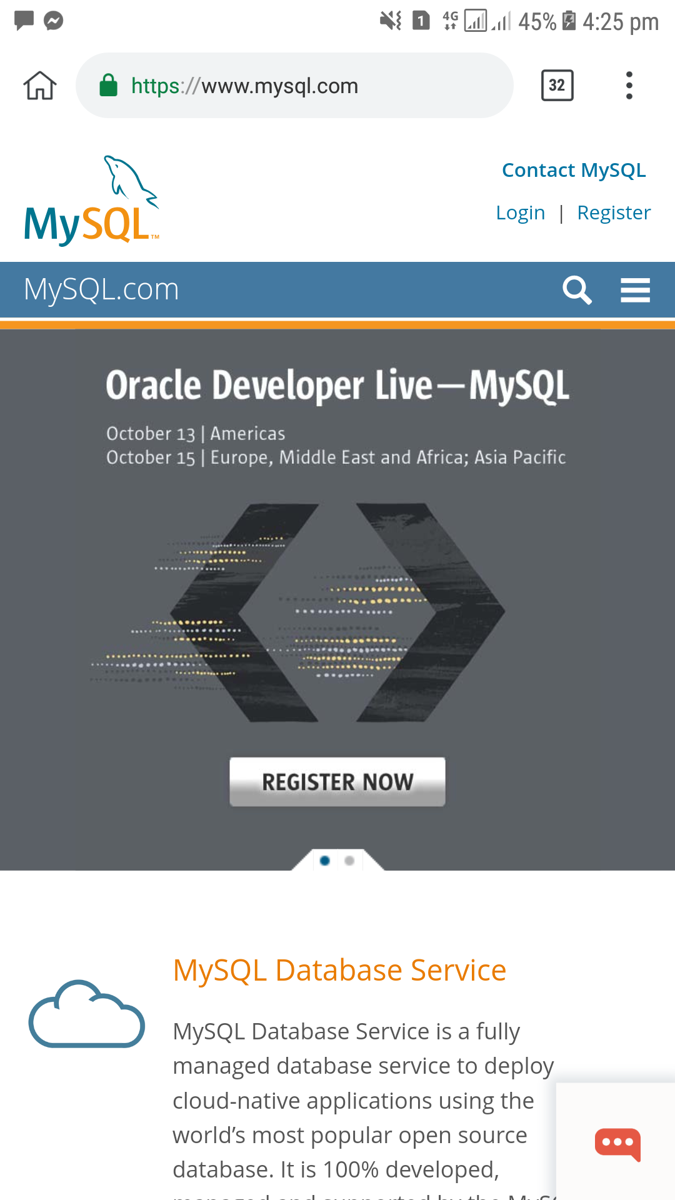

I chose SQL because this tool provides a mechanism which a user interact with the database without using query language.

2. Capture or make a screenshot for each types of interface given below and briefly explain its importance or benefits to the users.

a. Menu-Based Interface b. Forms-Based Interface

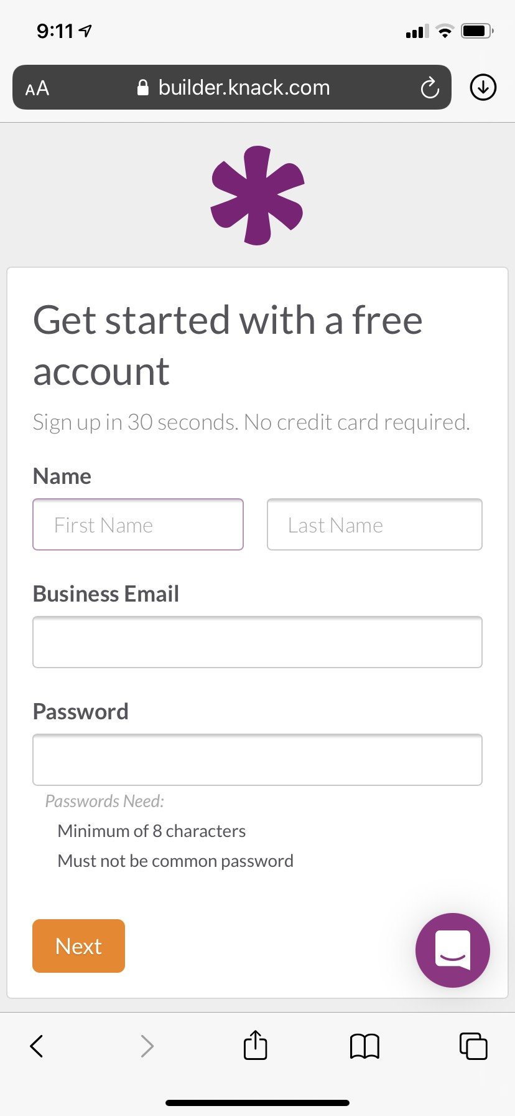

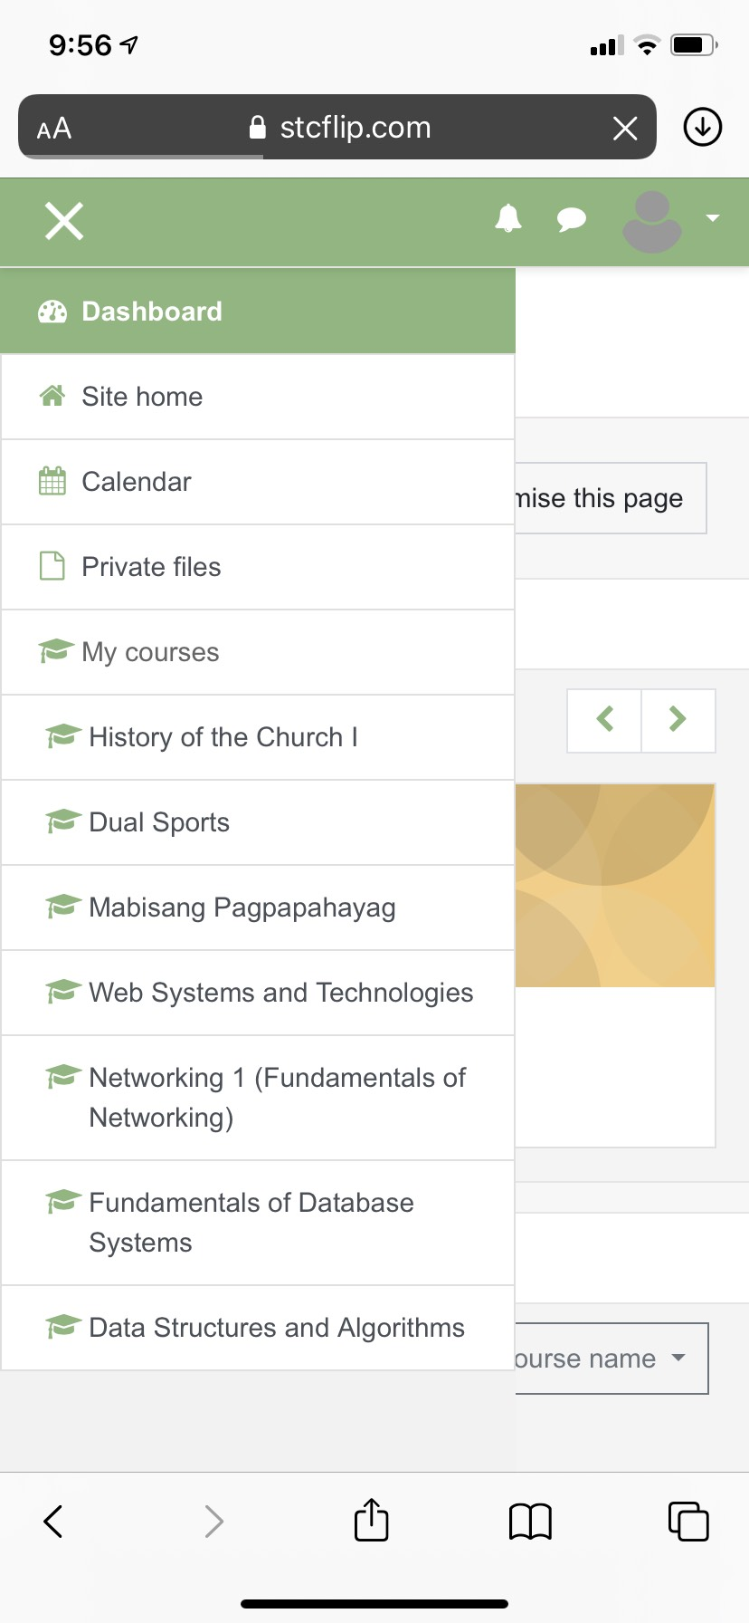

As you can see, this site has it's menus. When you click this site, first

When you click the bars either left or right, thing to show up is a sign up or

registration field before you can enter the menus will show up for the site.

user's options.

c. Graphical User Interface d. Natural Language Interface

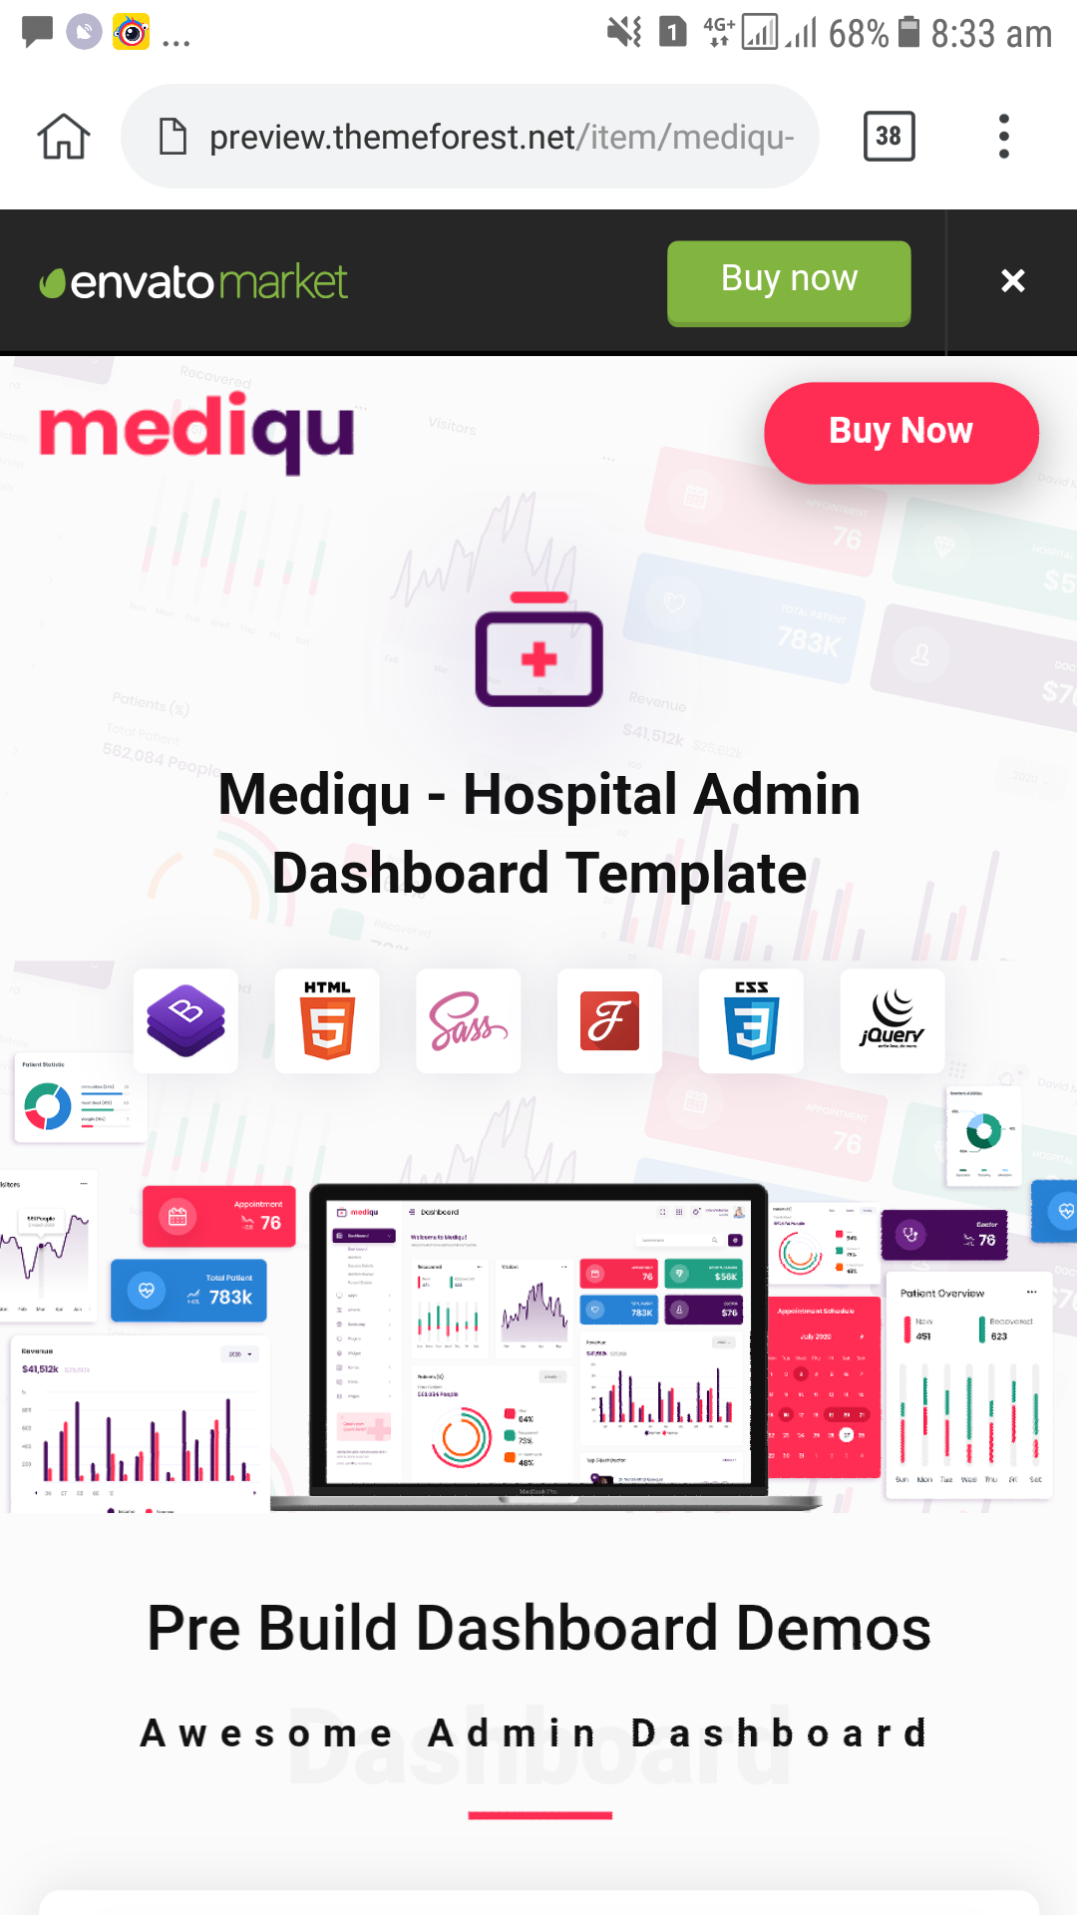



Graphical User Interface allows user to interact This interface allows you to

with electronic devices. As you can you can see, interact using a human language.

this site allows you to point your mouse or cursor Can be a command-based or a

to a particular icon. text-based interaction.

e. Speech input and output f. Interfaces for DBA

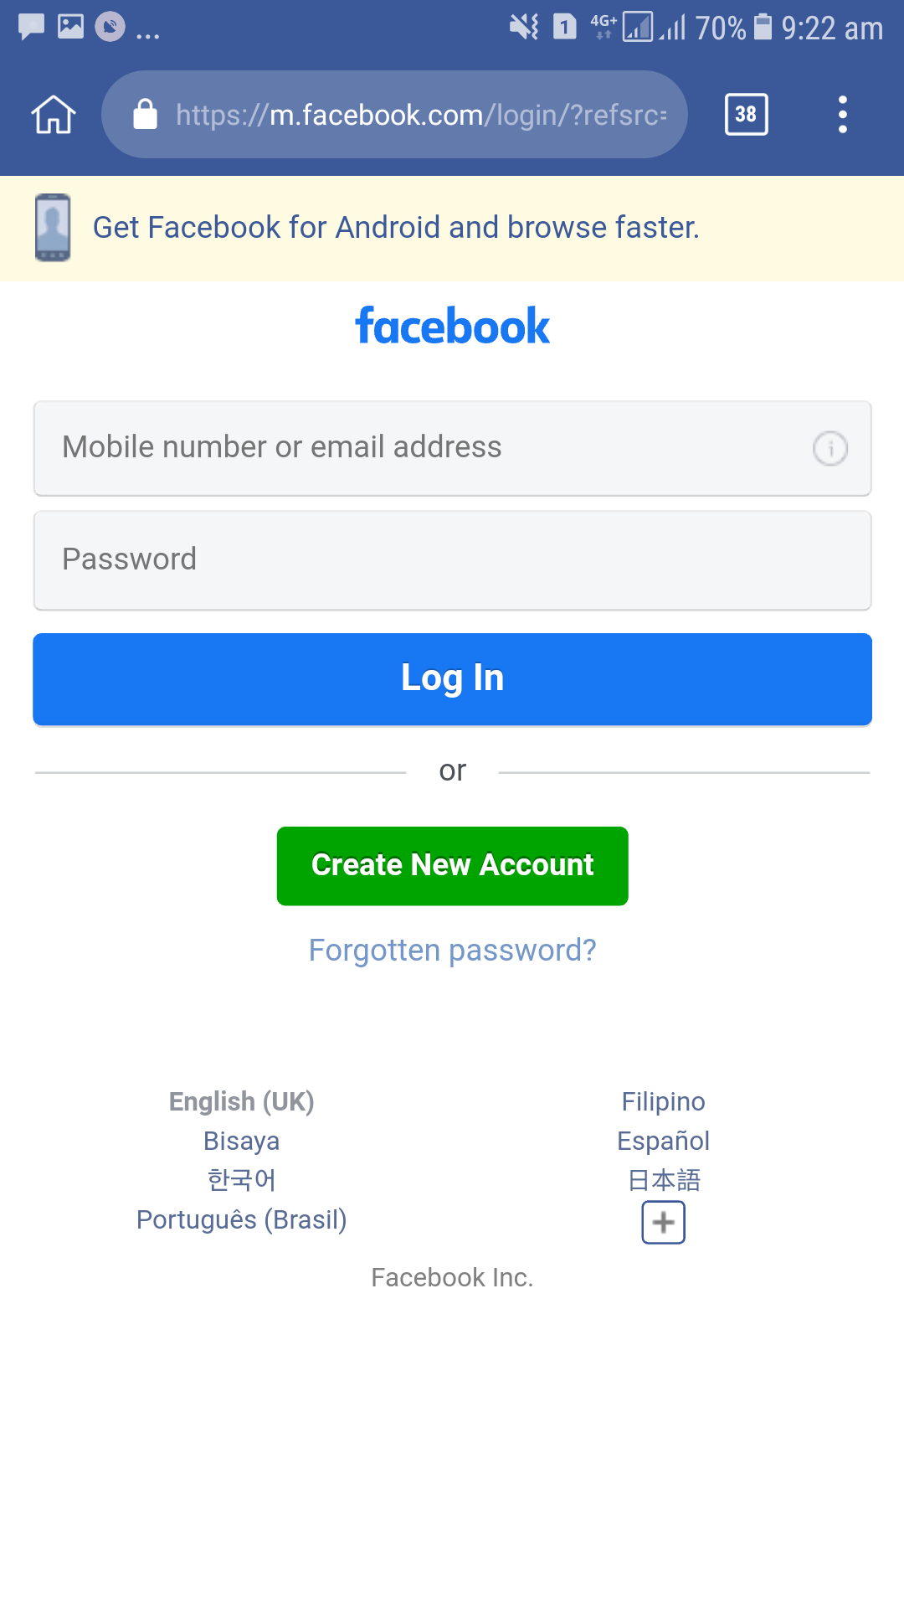

This interface simply allows the user to interact This last interface is simply an

with the system. As the user speaks, the system interface that creats account,

will be able to to recognise what was said. grants authorization, like facebook.

